**Unit 3**

**CDMA:** Code division multiple access systems apply codes with certain characteristics to the transmission to separate different users in code space and to enable access to a shared medium without interference.

All terminals send on the same frequency probably at the same time and can use the whole bandwidth of the transmission channel. Each sender has a unique random number, the sender XO‘s the signal with this random number. The receiver can “tune” into this signal if it knows the pseudo random number, tuning is done via a correlation function

Disadvantages:

* higher complexity of a receiver (receiver cannot just listen into the medium and start receiving if there is a signal)
* all signals should have the same strength at a receiver Advantages:
* all terminals can use the same frequency, no planning needed
* huge code space(eg. 232) compared to frequency space.
* interferences (e.g. white noise) is not coded
* forward error correction and encryption can be easily integrated.
* Sender A wants to transmit the bits 010011.

– sends Ad = 1, key Ak = 010011 (assign: “0”= -1, “1”= +1)

– sending signal As = Ad * Ak = (-1, +1, -1, -1, +1, +1)

* Sender B wants to transmit the bits 110101

– sends Bd = 0, key Bk = 110101 (assign: “0”= -1, “1”= +1)

– sending signal Bs = Bd * Bk = (-1, -1, +1, -1, +1, -1)

* Both signals superimpose in space as

– As + Bs = (-2, 0, 0, -2, +2, 0)

* Receiver wants to receive signal from sender A
  + apply key Ak bitwise (inner product)
    - Ae = (-2, 0, 0, -2, +2, 0)

Be = (-2, 0, 0, -2, +2, 0)

* + - Bk = -2 + 0 + 0 - 2 - 2 + 0 = -6, i.e. “0”

The following figure shows a sender A that wants to transmit the bits 101. The key of A is shown as signal and binary sequence Ak. The binary “0” is assigned a positive signal value, the binary “1” a negative signal value. After spreading, i.e., XORing Ad and Ak, the resulting signal is As.

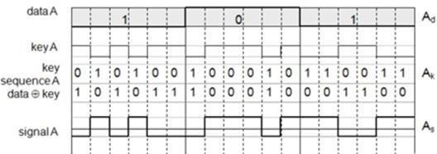.

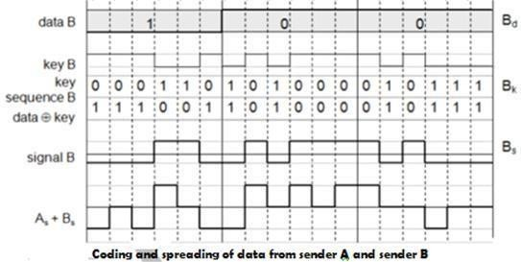

The same happens with data from sender B with bits 100. The result is Bs. As and Bs now superimpose during transmission. The resulting signal is simply the sum As + Bs as shown above. A now tries to reconstruct the original data from Ad. The receiver applies A’s key, Ak, to the received signal and feeds the result into an integrator. The integrator adds the products, a comparator then has to decide if the result is a 0 or a 1 as shown below. As clearly seen, although the original signal form is distorted by B’s signal, the result is quite clear. The same happens if a receiver wants to receive B’s data.

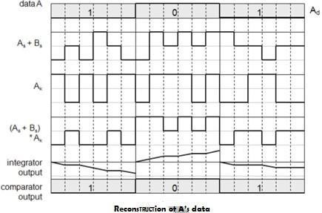

**Soft handover** or **soft handoff** refers to a feature used by the CDMA and WCDMA standards, where a cell phone is simultaneously connected to two or more cells (or cell sectors) during a call. If the sectors are from the same physical cell site (a sectorised site), it is referred to as **softer handoff**. This technique is a form of mobile-assisted handover, for IS-95/CDMA2000 CDMA cell phones continuously make power measurements of a list of neighboring cell sites, and determine

whether or not to request or end soft handover with the cell sectors on the list.

Soft handoff is different from the traditional hard-handoff process. With hard handoff, a definite decision is made on whether to hand off or not. The handoff is initiated and executed without the user attempting to have simultaneous traffic channel communications with the two base stations. With soft handoff, a c*onditional* decision is made on whether to hand off. Depending on the changes in pilot signal strength from the two or more base stations involved, a hard decision will eventually be made to communicate with only one. This normally happens after it is evident that the signal from one base station is considerably stronger than those from the others. In the interim period, the user has simultaneous traffic channel communication with all candidate base stations. It is desirable to implement soft handoff in power- controlled CDMA systems because implementing hard handoff is potentially difficult in such systems..

* 1. **Spread Aloha multiple access (SAMA)**

CDMA senders and receivers are not really simple devices. Communicating with *n* devices requires programming of the receiver to be able to decode *n* different codes. Aloha was a very simple scheme, but could only provide a relatively low bandwidth due to collisions. SAMA uses spread spectrum with only one single code (chipping sequence) for spreading for all senders accessing according to aloha.

In SAMA, each sender uses the same spreading code, for ex 110101 as shown below. Sender A and B access the medium at the same time in their narrowband spectrum, so that the three bits

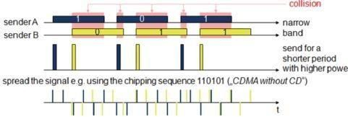

The main problem in using this approach is finding good chipping sequences. The maximum throughput is about 18 per cent, which is very similar to Aloha, but the approach benefits from the advantages of spread spectrum techniques: robustness against narrowband interference and simple coexistence with other systems in the same frequency bands.

* 1. **Wireless LAN/(IEEE 802.11)**

The global goal of WLANs is to replace office cabling, to enable tether less access to the internet and, to introduce a higher flexibility for ad-hoc communication in, e.g., group meetings. **Advantages**

* **Flexibility:** Within radio coverage, nodes can communicate without further restriction. Radio waves can penetrate walls, senders and receivers can be placed anywhere (also non-visible, e.g., within devices, in walls etc.).
* **Planning:** Only wireless ad-hoc networks allow for communication without previous planning, any wired network needs wiring plans. As long as devices follow the same standard, they can communicate
* **Design:** Wireless networks allow for the design of small, independent devices which can for example be put into a pocket. Cables not only restrict users but also designers of small PDAs, notepads etc.
* **Robustness:** Wireless networks can survive disasters, e.g., earthquakes or users pulling a plug. If the wireless devices survive, people can still communicate. Networks requiring a wired infrastructure will usually break down completely.
* **Cost:** After providing wireless access to the infrastructure via an access point for the first user, adding additional users to a wireless network will not increase the cost. This is, important for e.g., lecture halls, hotel lobbies or gate areas in airports where the numbers using the network may vary significantly.

Disadvantages:

* **Quality of service:** WLANs typically offer lower quality than their wired counterparts. The main reasons for this are the lower bandwidth due to limitations in radio transmission (e.g., only 1–10 Mbit/s user data rate instead of 100–1,000 Mbit/s), higher error rates due to interference (e.g., 10–4 instead of 10–12 for fiber optics), and higher delay/delay variation due to extensive error correction and detection mechanisms.
* **Proprietary solutions:** Due to slow standardization procedures, many companies have come up with proprietary solutions offering standardized functionality plus many enhanced features (typically a higher bit rate using a patented coding technology or special inter-access point protocols).
* **Restrictions:** All wireless products have to comply with national regulations. Several government and non-government institutions worldwide regulate the operation and restrict frequencies to minimize interference.
* **Safety and security:** Using radio waves for data transmission might interfere with other high-tech
* **Global operation:** WLAN products should sell in all countries so, national and international frequency regulations have to be considered.
* **Low power:** Devices communicating via a WLAN are typically also wireless devices running on battery power. The LAN design should take this into account and implement special power-saving modes and power management functions.
* **License-free operation:** LAN operators do not want to apply for a special license to be able to use the product. The equipment must operate in a license-free band, such as the 2.4 GHz ISM band.
* **Robust transmission technology:** Compared to their wired counterparts, WLANs operate under difficult conditions. If they use radio transmission, many other electrical devices can interfere with them (vacuum cleaners, hairdryers, train engines etc.).
* **Simplified spontaneous cooperation:** To be useful in practice, WLANs should not require complicated setup routines but should operate spontaneously after power-up. These LANs would not be useful for supporting, e.g., ad-hoc meetings.
* **Easy to use:** In contrast to huge and complex wireless WANs, wireless LANs are made for simple use. They should not require complex management, but rather work on a plug-and-play basis.
* **Protection of investment:** A lot of money has already been invested into ,wired LANs. The new WLANs should protect this investment by being interoperable with the existing networks.
* **Safety and security:** Wireless LANs should be safe to operate, especially regarding low radiation if used, e.g., in hospitals. Users cannot keep safety distances to antennas.
* **Transparency for applications:** Existing applications should continue to run over WLANs, the only

difference being higher delay and lower bandwidth. The fact of wireless access and mobility should be hidden if it is not relevant, but the network should also support location aware applications, e.g., by providing location information.

IEEE 802.11

The IEEE standard 802.11 (IEEE, 1999) specifies the most famous family of WLANs in which many products are available. As the standard’s number indicates, this standard belongs to the group of 802.x LAN standards, e.g., 802.3 Ethernet or 802.5 Token Ring. This means that the standard specifies the physical and medium access layer adapted to the special requirements of wireless LANs, but offers the same interface as the others to higher layers to maintain interoperability.

The primary goal of the standard was the specification of a simple and robust WLAN which offers time-bounded and asynchronous services. The MAC layer should be able to operate with multiple physical layers, each of which exhibits a different medium sense and transmission characteristic. Candidates for physical layers were infrared and spread spectrum radio transmission techniques.

Additional features of the WLAN should include the support of power management to save battery power, the handling of hidden nodes, and the ability to operate worldwide. The 2.4 GHz ISM band, which is available in most countries around the world, was chosen for the original standard. Data rates envisaged forth standard were 1 Mbit/s mandatory and 2 Mbit/s optional.

The following sections will introduce the system and protocol architecture of the initial IEEE

802.11 and then discuss each layer, i.e., physical layer and medium access. After that, the complex and very important management functions of the standard are presented. Finally, this subsection presents the enhancements of the original standard for higher data rates, 802.11a (up

Wireless networks can exhibit two different basic system architectures as shown in infrastructure- based or ad-hoc. Figure shows the components of an infrastructure and a wireless part

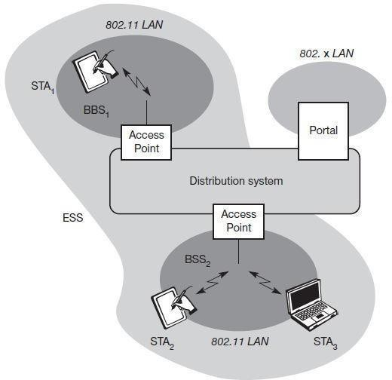as specified for IEEE 802.11. Several nodes, called **stations (STAi)**, are connected to **access points (AP)**. Stations are terminals with access mechanisms to the wireless medium and radio contact to the AP. The stations and the AP which are within the same radio coverage form a **basic service set (BSSi)**. The example shows two BSSs – BSS1 and BSS2 – which are connected via a **distribution system**. ***Figure:*** *Architecture of an infrastructure-*

*based IEEE 802.11*

A distribution system connects several BSSs via the AP to form a single network and thereby extends the wireless coverage area. This network is now called an **extended service set (ESS)** and has its own identifier, the ESSID. The ESSID is the ‘name’ of a network and is used to separate different networks. Without knowing the ESSID (and assuming no hacking) it should not be possible to participate in the WLAN. The distribution system connects the wireless networks via the APs with a **portal**, which forms the interworking unit to other LANs. The architecture of the distribution system is not specified further in IEEE 802.11. It could

consist of bridged IEEE LANs, wireless links, or any other networks. However, **distribution system services** are defined in the standard (although, many products today cannot interoperate and needs the additional standard IEEE 802.11f to specify an inter access point protocol. Stations can select an AP and associate with it. The APs support roaming (i.e., changing access points), the distribution system handles data transfer between the different APs. APs provide synchronization within a BSS, support power management, and can control medium access to support time-bounded service. These and further functions are explained in the following sections.

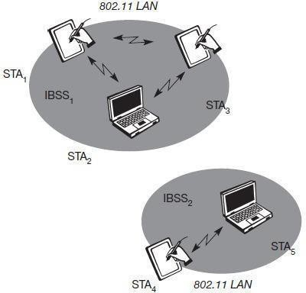In addition to infrastructure-based networks, IEEE 802.11 allows the building of ad-hoc networks between stations, thus forming one or mor

e

independent BSSs (IBSS) as **shown in Figure**. In this case, an IBSS comprises a group of stations using the same radio frequency. Stations STA1, STA2, and STA3 are in IBSS1, STA4 and STA5 in IBSS2. This means for example that STA3 can communicate directly with STA2 but not with STA5. Several IBSSs can either be formed via the distance between the IBSSs or by using different carrier frequencies (then the IBSSs could overlap physically). IEEE 802.11 does not specify any special nodes that support routing, forwarding of data or exchange of topology information as, e.g., HIPERLAN 1 or Bluetooth.

Protocol architecture:

***Figure:***

*Architectu re of EEE 802.11 ad- hoc wireless LANs*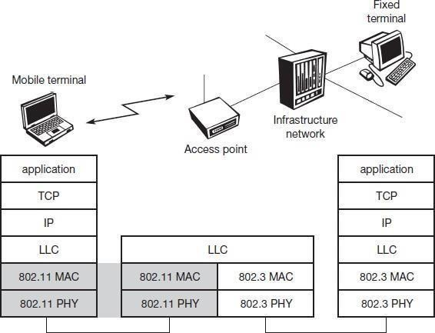

***Figure:*** *IEEE 802.11 protocol architecture and bridging*

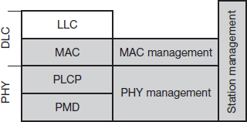

***Figure****: Detailed IEEE 802.11 protocol architecture and management*

As indicated by the standard number, IEEE 802.11 fits seamlessly into the other 802.x standards for wired LANs Figure shows the most common scenario: an IEEE 802.11 wireless LAN connected to a switched IEEE 802.3 Ethernet via a bridge. Applications should not notice any difference apart from the lower bandwidth and perhaps higher access time from the wireless LAN. The WLAN behaves like a slow wired LAN. Consequently, the higher layers (application, TCP, IP) look the same for wireless nodes as for wired nodes. The upper part of the data link control layer, the logical link control (LLC), covers the differences of the medium access control layers needed for the different media. In many of today’s networks, no explicit LLC layer is visible. Further details like Ether type or sub-network access protocol (SNAP) and bridging technology are explained in, e.g., Perlman (1992).

The IEEE 802.11 standard only covers the physical layer **PHY** and medium access layer **MAC** like the other 802.x LANs do. The physical layer is subdivided into the **physical layer convergence protocol (PLCP)** and the **physical medium dependent** sublayer **PMD**. The basic tasks of the MAC layer comprise medium access, fragmentation of user data, and encryption. The PLCP sublayer provides a carrier sense signal, called clear channel assessment (CCA), and provides a common PHY service access point (SAP) independent of the transmission technology. Finally, the PMD sublayer handles modulation and

encoding/decoding of signals. The PHY layer (comprising PMD and PLCP) and the MAC layer will be explained in more detail in the following sections.

Apart from the protocol sublayers, the standard specifies management layers and the station management. The **MAC anagement** supports the association and re-association of a station to an access point and roaming between different access points. It also controls authentication mechanisms, encryption, synchronization of a station with regard to an access point, and power management to save battery power. MAC management also maintains the MAC management information base (MIB).

The main tasks of the **PHY management** include channel tuning and PHY MIB maintenance. Finally, **station management** interacts with both management layers and is responsible for additional higher layer functions (e.g., control of bridging

and interaction with the distribution system in the case of an access point).

2.16. Comparison SDMA/TDMA/FDMA/CDMA

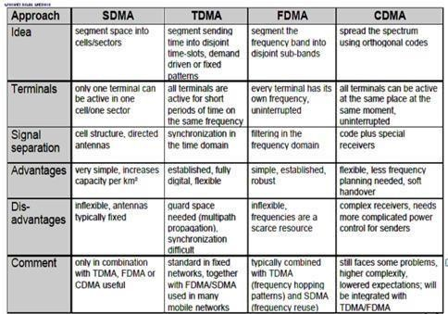

Need for Mobile IP

The IP addresses are designed to work with stationary hosts because part of the address defines the network to which the host is attached***.*** A host cannot change its IP address without terminating on-going sessions and restarting them after it acquires a new address. Other link layer mobility solutions exist but are not sufficient enough for the global Internet.

*Mobility* is the ability of a node to change its point-of-attachment while maintaining allexisting communications and using the same IP address.

*Nomadicity* allows a node to move but it must terminate all existing communicationsand then can initiate new connections with a new address.

*Mobile IP is a network layer solution for homogenous and heterogeneous mobility on the global Internet which is scalable, robust, secure and which allows nodes to maintain all ongoing communications while moving.*

**Design Goals**: Mobile IP was developed as a means for transparently dealing with problems of mobile users. Mobile IP was designed to make the size and the frequency of required routing updates as small as possible. It was designed to make it simple to implement mobile node software. It was designed to avoid solutions that require mobile nodes to use multiple addresses.

**Requirements**: There are several requirements for Mobile IP to make it as a standard. Someof them are:

1. *Compatibility*: The whole architecture of internet is very huge and a new standard cannot introduce changes to the applications or network protocols already in use. Mobile IP is to be integrated into the existing operating systems. Also, for routers also it may be possible to enhance its capabilities to support mobility instead of changing the routers which is highly impossible. Mobile IP must not require special media or MAC/LLC protocols, so it must use the same interfaces and mechanisms to access the lower layers as IP does. Finally, end-systems enhanced with a mobile IP implementation should still be able to communicate with fixed systems without mobile IP.
2. *Transparency*: Mobility remains invisible for many higher layer protocols and applications. Higher layers continue to work even if the mobile computer has changed its point of attachment to the network and even notice a lower bandwidth and some interruption in the service. As many of today’s applications have not been designed to use in mobile environments, the effects of mobility will be higher delay and lower bandwidth.
3. *Scalability and efficiency*: The efficiency of the network should not be affected evenif a new mechanism is introduced into the internet. Enhancing IP for mobility mustnot generate many new messages flooding the whole network. Special care is necessary to be taken considering the lower bandwidth of wireless links. Many mobile systems have a wireless link to an attachment point. Therefore, only some additional packets must be necessary between a mobile system and a node in the network. It is indispensable for a mobile IP to be scalable over a large number of participants in the whole internet, throughout the world.
4. *Security*: Mobility possesses many security problems. A minimum requirement is the authentication of all messages related to the management of mobile IP. It must be sure for the IP layer if it forwards a packet to a mobile host that this host really is the receiver of the packet. The IP layer can only guarantee that the IP address of the receiver is correct. There is no way to prevent faked IP addresses and other attacks.

The goal of a mobile IP can be summarized as: ‘supporting end-system mobility while maintaining scalability, efficiency, and compatibility in all respects with existing applications and Internet protocols’.

**Entities and terminology**

The following defines several entities and terms needed to understand mobile IP as defined in RFC 3344.

**Mobile Node (MN):** A mobile node is an end-system or router that can change its point

of attachment to the internet using mobile IP. The MN keeps its IP address and can continuously communicate with any other system in the internet as long as link-layer connectivity is given. Examples are laptop, mobile phone, router on an aircraft etc.

**Correspondent node (CN):** At least one partner is needed for communication. In the following the CN represents this partner for the MN. The CN can be a fixed or mobile node.

**Home network:** The home network is the subnet the MN belongs to with respect to itsIP address. No mobile IP support is needed within the home network.

**Foreign network:** The foreign network is the current subnet the MN visits and which isnot the home network.

2

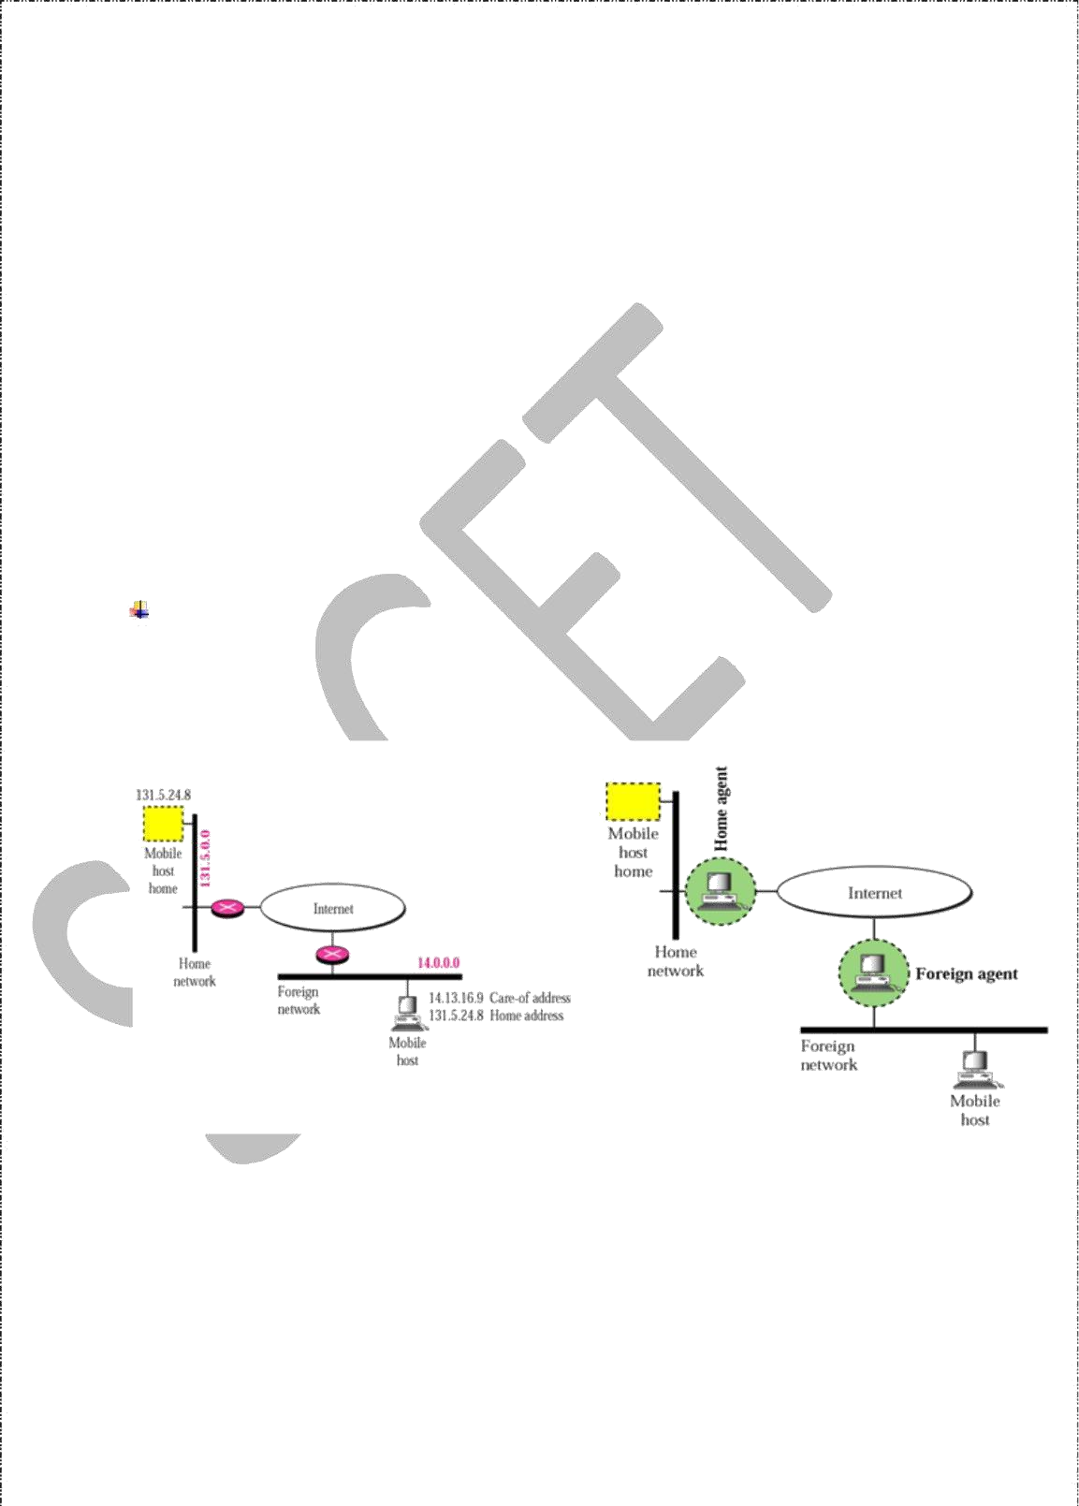

**Foreign agent (FA):** The FA can provide several services to the MN during its visit to the foreign network. The FA can have the COA, acting as tunnel endpoint and forwarding packets to the MN. The FA can be the default router for the MN. FAs can also provide security services because they belong to the foreign network as opposed to the MN which is only visiting. FA is implemented on a router for the subnet the MN attaches to.

**Care-of address (COA):** The COA defines the current location of the MN from an IP point of view. All IP packets sent to the MN are delivered to the COA, not directly to theIP address of the MN. Packet delivery toward the MN is done using a tunnel, i.e., the COAmarks the tunnel endpoint, i.e., the address where packets exit the tunnel. There are twodifferent possibilities for the location of the COA:

**Foreign agent COA:** The COA could be located at the FA, i.e., the COA is an IP

address of the FA. The FA is the tunnel end-point and forwards packets to the MN. Many MN using the FA can share this COA as common COA.

**Co-located COA:** The COA is co-located if the MN temporarily acquired an additional IP address which acts as COA. This address is now topologically correct,and the tunnel endpoint is at the MN. Co-located addresses can be acquired using services such as DHCP.

**Home agent (HA):** The HA provides several services for the MN and is located in the home network. The tunnel for packets toward the MN starts at the HA. The HA maintainsa location registry, i.e., it is informed of the MN’s location by the current COA. Three alternatives for the implementation of an HA exist.

1. The HA can be implemented on a router that is responsible for the home network. This is obviously the best position, because without optimizations to mobile IP, all packets for t3he

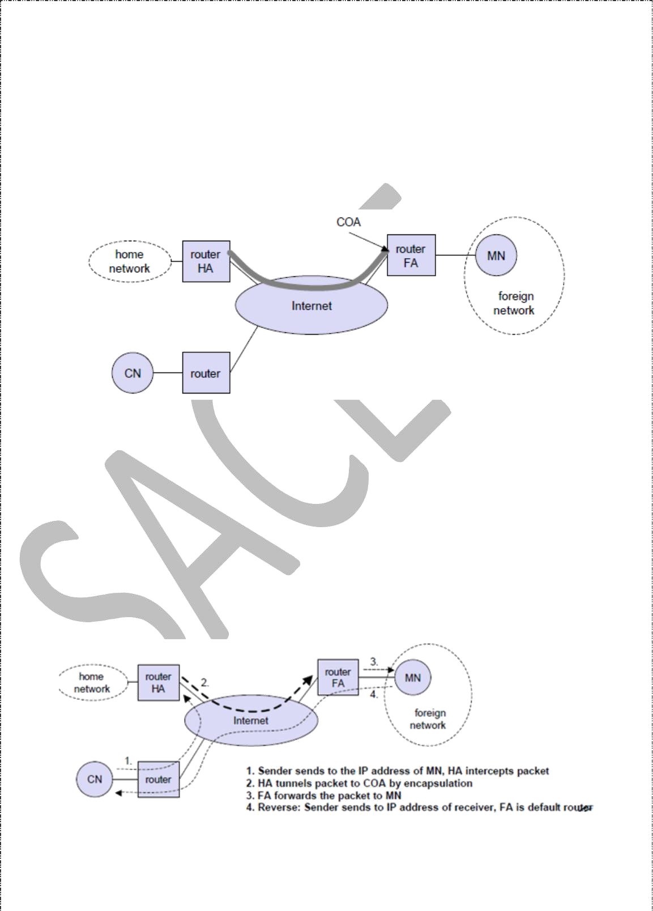MN have to go through the router anyway.

1. If changing the router’s software is not possible, the HA could also be implemented

on an arbitrary node in the subnet. One disadvantage of this solution is the double

crossing of the router by the packet if the MN is in a foreign network. A packet forthe MN comes in via the router; the HA sends it through the tunnel which again crosses the router.

1. Finally, a home network is not necessary at all. The HA could be again on the ‘router’ but this time only acting as a manager for MNs belonging to a virtual home network. All MNs are always in a foreign network with this solution.

A CN is connected via a router to the internet, as are the home network and the foreign network. The HA is implemented on the router connecting the home network with the internet, an FA is implemented on the router to the foreign network. The MN is currently in the foreign network. The tunnel for packets toward the MN starts at the HA and ends at the FA, for the FA has the COA in the above example.

**IP packet delivery and Handover Management**

Consider the above example in which a correspondent node (CN) wants to send an IP packet to the MN. One of the requirements of mobile IP was to support hiding the mobility of the MN. CN does not need to know anything about the MN’s current location and sends the packet as usual to the IP address of MN as shown below.

4

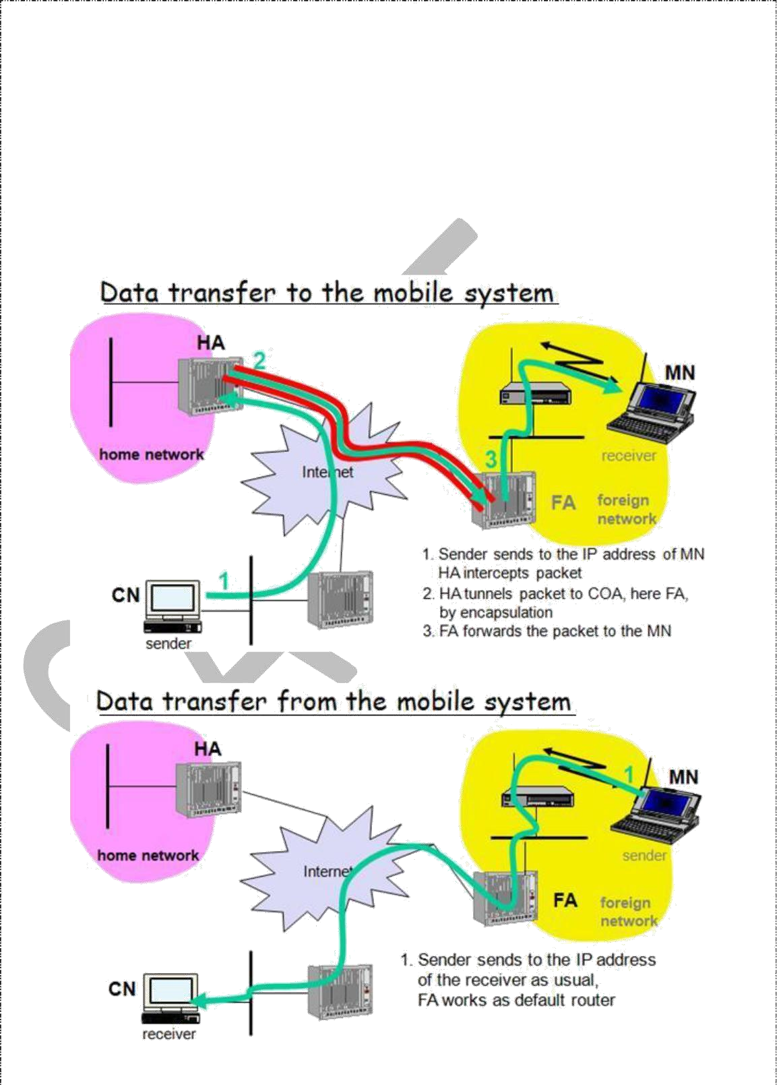CN sends an IP packet with MN as a destination address and CN as a source address. Theinternet, not having information on the current location of MN, routes the packet to the router responsible for the home network of MN. This is done using the standard

routing mechanisms of the internet. The HA now intercepts the packet, knowing that MN is currently not in its home network. The packet is not forwarded into the subnet as usual, but encapsulated and tunnelled to the COA. A new header is put in front of the old IP header showing the COA as new destination and HA as source of the encapsulated packet (step 2).

The foreign agent now decapsulates the packet, i.e., removes the additional header, and forwards the original packet with CN as source and MN as destination to the MN (step 3). Again, for the MN mobility is not visible. It receives the packet with the same sender and receiver address as it would have done in the home network.

Sending packets from the mobile node (MN) to the CN is comparatively simple. The MN sends the packet as usual with its own fixed IP address as source and CN’s address as destination (step 4). The router with the FA acts as default router and forwards the packet in the same way as it would do for any other node in the foreign network. As long as CN is a fixed node the remainder is in the fixed internet as usual. If CN were also a mobile node residing in a foreign network, the same mechanisms as described in steps 1 through 3 would apply now in the other direction.

Working of Mobile IP:- Mobile IP has two addresses for a mobile host: one home address and one care- of address. The home address is permanent; the care-of address changes as the mobile host movesfrom one network to another. To make the change of address transparent to the rest of the Internet requires a home agent and a foreign agent. The specific function of an agent is performed in the application layer. When the mobile host and the foreign agent are the same, the care-of address is called a co-located care-of address. To communicate with a remote host, a mobile host goes through three phases: agent discovery, registration, and data transfer.

**Agent Discovery**

A mobile node has to find a foreign agent when it moves away from its home network. To solve this problem, mobile IP describes two methods: agent advertisement and agent solicitation.

Agent advertisement

For this method, foreign agents and home agents advertise their presence periodically using special **agent advertisement** messages, which are broadcast into the subnet. Mobile IP does not use a new packet type for agent advertisement; it uses the router advertisement packet of ICMP, and appends an agent advertisement message. The agent advertisement packet according to RFC 1256 with the extension for mobility is shown below:

The TTL field of the IP packet is set to 1 for all advertisements to avoid forwarding them. The **type** is set to 9, the **code** can be 0, if the agent also routes traffic from non-mobile nodes, or 16, if it does not route anything other than mobile traffic. The number of addresses advertised with this packet is in **#addresses** while the **addresses** themselves follow as shown. **Lifetime** denotes the length of time this advertisement is valid. **Preference** levels for each address help a node to choose the router that is the most eager one to get a new node.

The extension for mobility has the following fields defined: **type** is set to 16, **length** depends on the number of COAs provided with the message and equals 6 + 4*(number of addresses). The **sequence number** shows the total number of advertisements sent since initialization by the agent. By the **registration lifetime** the agent can specify the maximum lifetime in seconds a node can request during registration. The following bits specify the characteristics of an agent in detail.

The **R** bit (registration) shows, if a registration with this agent is required even when using a colocated COA at the MN. If the agent is currently too busy to accept new registrations it can set the **B** bit. The following two bits denote if the agent offers services as a home agent (**H**) or foreign agent (**F**) on the link where the advertisement has been sent. Bits M and G specify the method of encapsulation used for the tunnel. While IP-in-IP encapsulation is the mandatory standard, **M** can specify minimal encapsulation and **G** generic routing encapsulation. In the first version of mobile IP (RFC 2002) the **V** bit specified the use of header compression according to RFC 1144. Now the field **r** at the same bit position is set to zero and must be ignored. The new field **T** indicates that reverse tunnelingis supported by the FA. The following fields contain the **COAs** advertised. A foreign agent setting the F bit must advertise at least one COA. A mobile node in a subnet can now receive agent advertisements from either its home agent or a foreign agent. This is one way for the MN to discover its location.

Agent Solicitation

If no agent advertisements are present or the inter-arrival time is too high, and an MN has not received a COA by other means, the mobile node must send **agent solicitations**. Care must be taken to ensure that these solicitation messages do not flood the network, but basically an MN can search for an FA endlessly sending out solicitation messages. If a node does not receive an answer to its solicitations it must decrease the rate of solicitations exponentially to avoid flooding the network until it reaches a maximum interval between

solicitations (typically one minute). Discovering a new agent can be done anytime, not just if the MN is not connected to one.

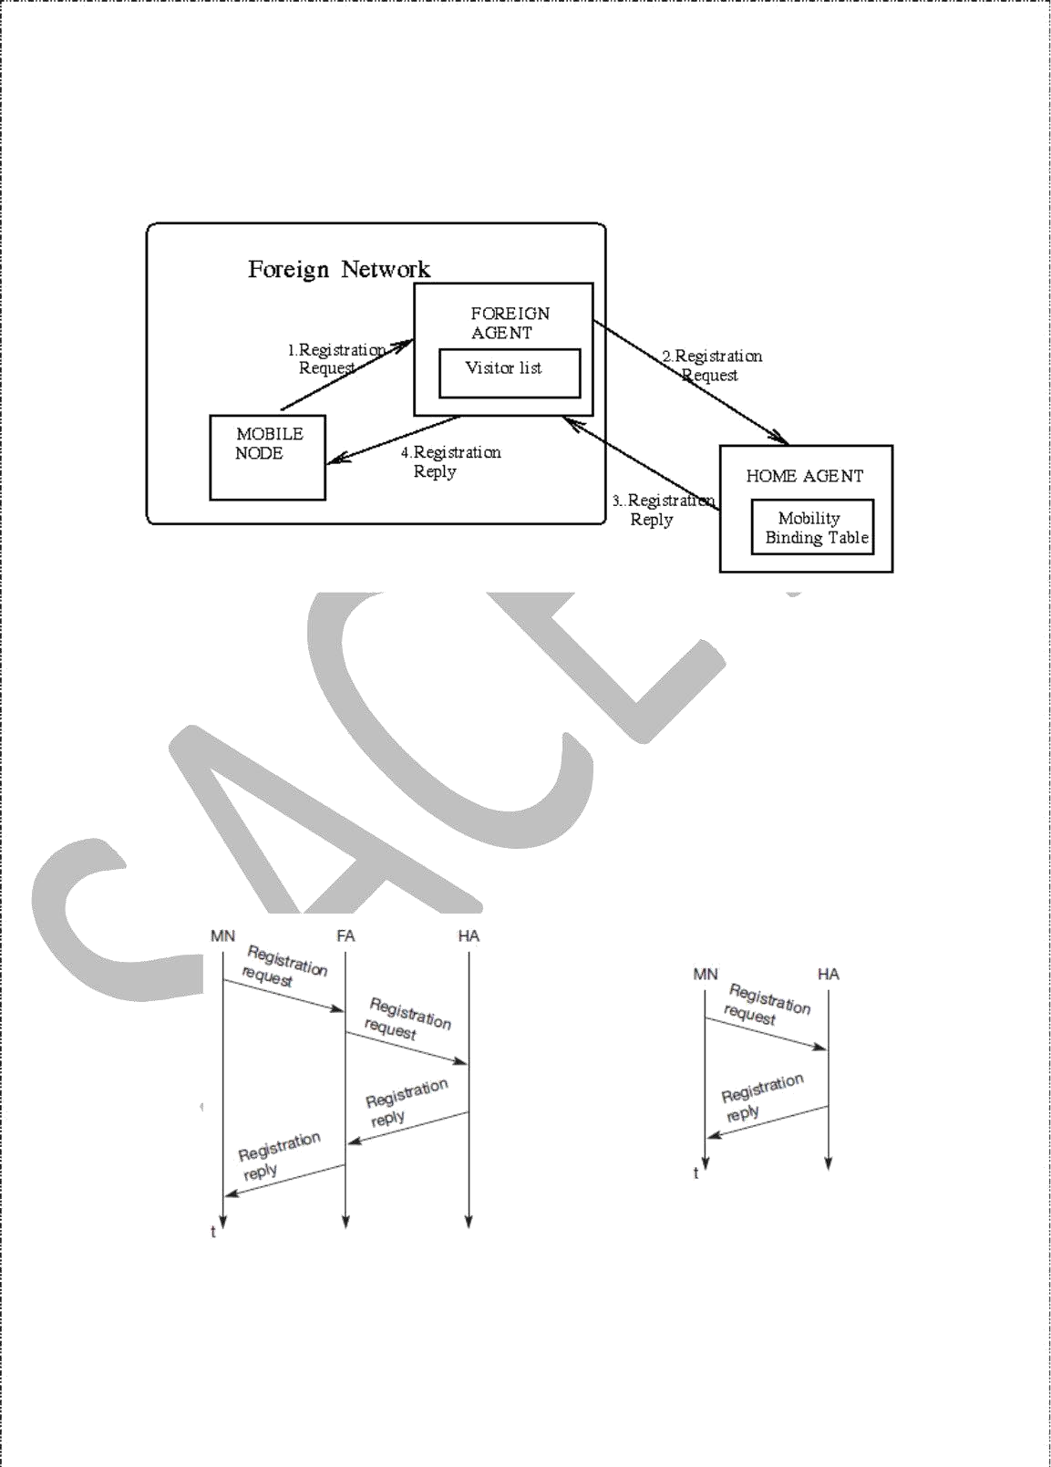

After these steps of advertisements or solicitations the MN can now receive a COA,either one for an FA or a co-located COA.

7

# Agent Registration

Having received a COA, the MN has to register with the HA. The main purpose of the registration is to inform the HA of the current location for correct forwarding of packets.

Registration can be done in two different ways depending on the location of the COA.

If the COA is at the FA, the MN sends its registration request containing the COA to the FA which forwards the request to the HA. The HA now sets up a **mobility binding,** containing the mobile node’s home IP address and the current COA. It also contains the lifetime of the registration which is negotiated during the registration process. Registration expires automatically after the lifetime and is deleted; so, an MN should reregister before expiration. This mechanism is necessary to avoid mobility binding s which are no longer used. After setting up the mobility binding, the HA sends a reply message back to the FA which forwards it to the MN.

If the COA is co-located, registration can be simpler, the MN sends the request directly to the HA and vice versa. This is also the registration procedure for MNs returning to their home network to register directly with the HA.

**Registration of a mobile node via the FA or directly with the HA**

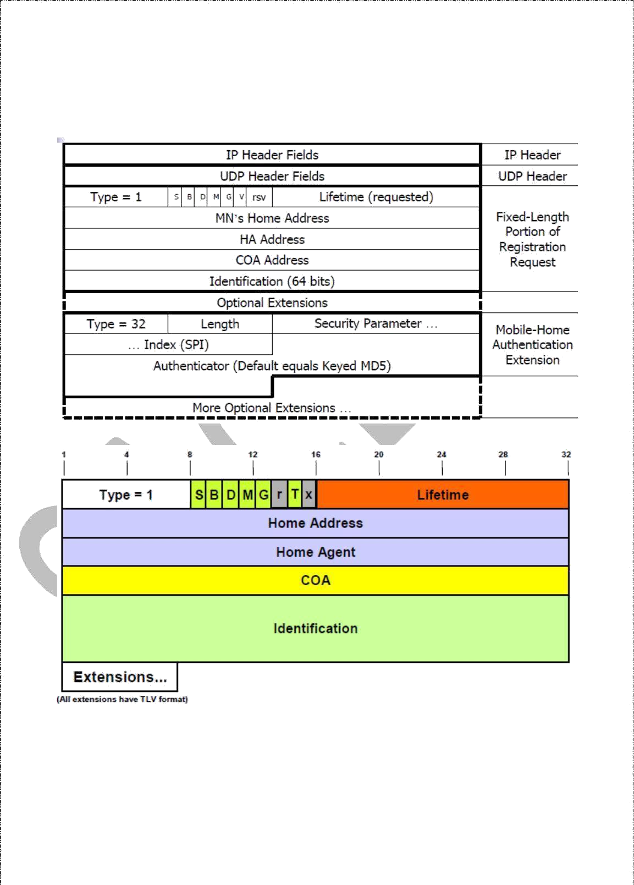

UDP packets are used for the registration requests using the port no 434. The IP source address of the packet is set to the interface address of the MN, the IP destination address is that of the FA or HA.

**Registration Request**

9

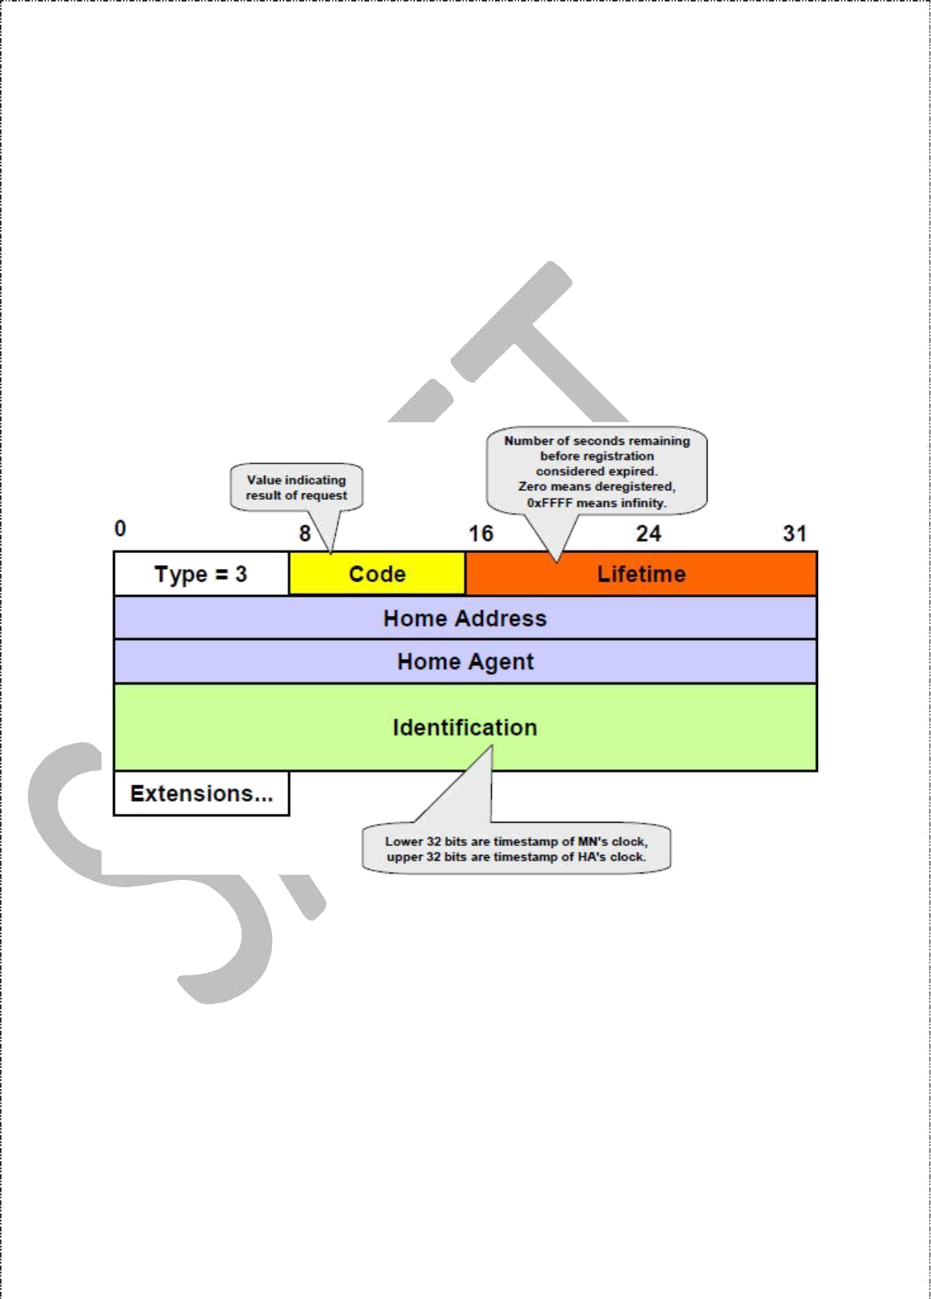The first field **type** is set to 1 for a registration request. With the **S** bit an MN can specify if it wants the HA to retain prior mobility bindings. This allows for simultaneous bindings. Setting the **B** bit generally indicates that an MN also wants to receive the broadcastpackets which have been received by the HA in the home network. If an MN uses a co- located COA, it also takes care of the decapsulation at the tunnel endpoint. The **D** bit indicates this behavior. As already defined for agent advertisements, the bits **M** and **G** denote the use of minimal encapsulation or generic routing encapsulation, respectively. **T**

indicates reverse tunneling, **r** and **x** are set to zero.

**Lifetime** denotes the validity of the registration in seconds. A value of zero indicates deregistration; all bits set indicates infinity. The **home address** is the fixed IP address of the MN, **home agent** is the IP address of the HA, and **COA** represents the tunnel endpoint. The

64 bit **identification** is generated by the MN to identify a request and match it with registration replies. This field is used for protection against replay attacks of registrations. The **extensions** must at least contain parameters for authentication

A **registration reply**, which is conveyed in a UDP packet, contains a **type** field set to3 and a **code** indicating the result of the registration request.

10

**Registration Reply**

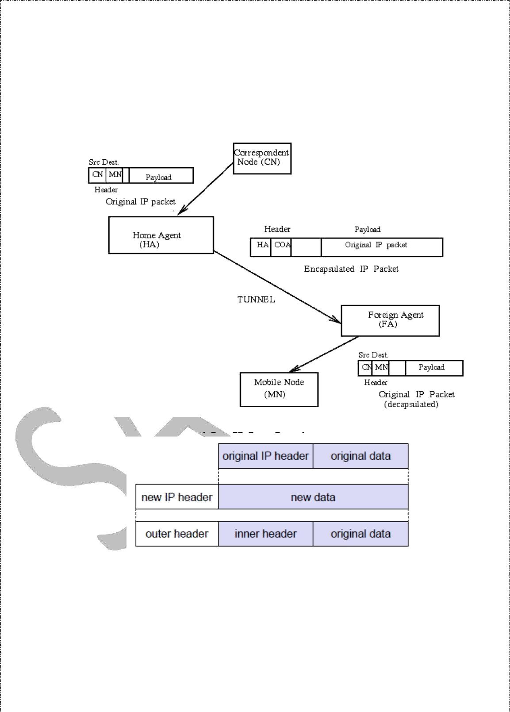

The **lifetime** field indicates how many seconds the registration is valid if it was successful. **Home address** and **home agent** are the addresses of the MN and the HA, respectively. The 64-bit **identification** is used to match registration requests with replies. The value is based on the identification field from the registration and the authentication method. Again, the **extensions** must at least contain parameters for authentication.

10